**Assignment 12**

**Data Science Masters**

**Read the following data set:**

**https://archive.ics.uci.edu/ml/machine-learning-databases/adult/**

**Rename the columns as per the description from this file:**

[**https://archive.ics.uci.edu/ml/machine-learning-databases/adult/adult.names**](https://archive.ics.uci.edu/ml/machine-learning-databases/adult/adult.names)

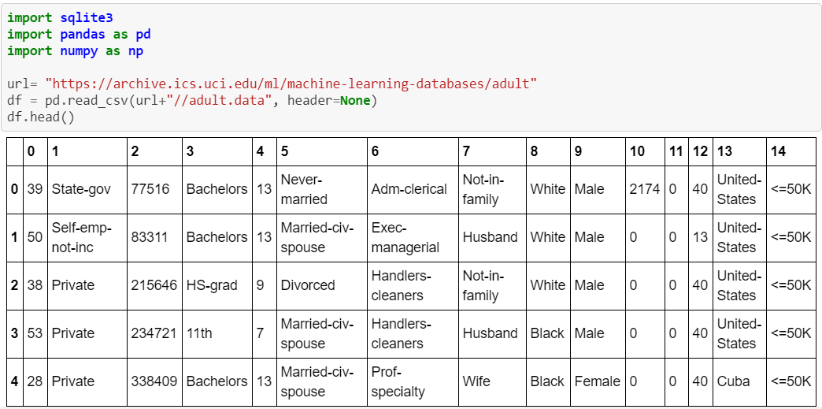

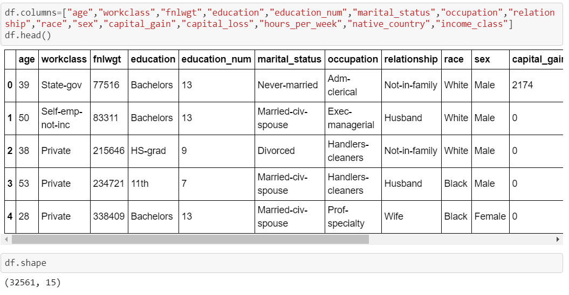

**Task:**

**Create a sql db from adult dataset and name it sqladb**

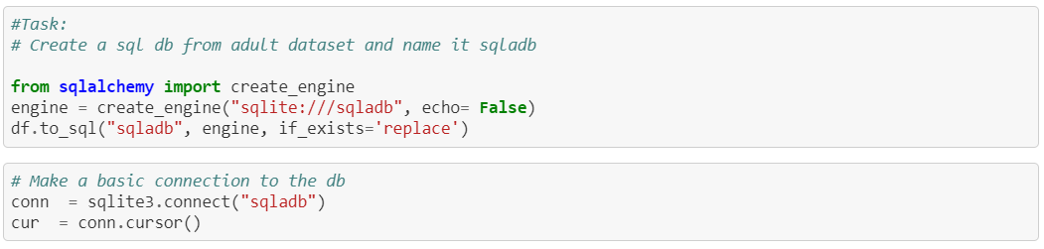

**1. Select 10 records from the adult sqladb**

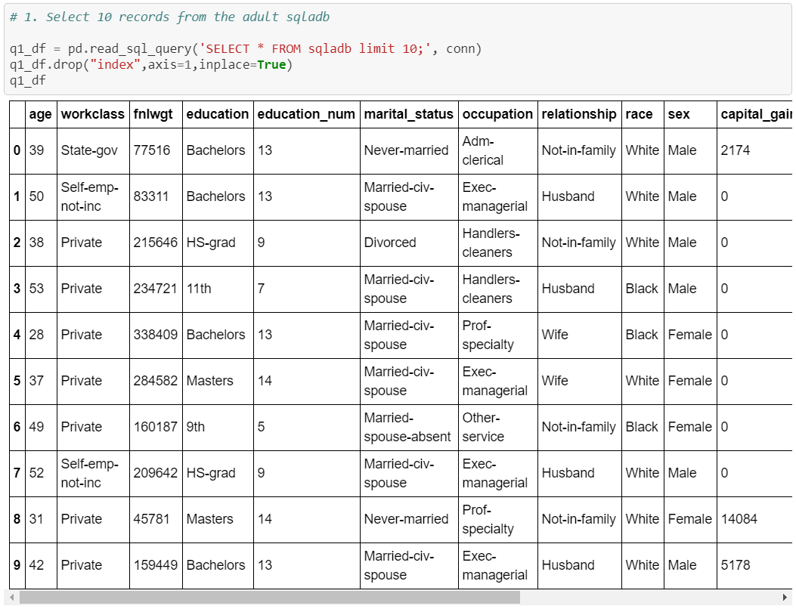

**2. Show me the average hours per week of all men who are working in private sector**

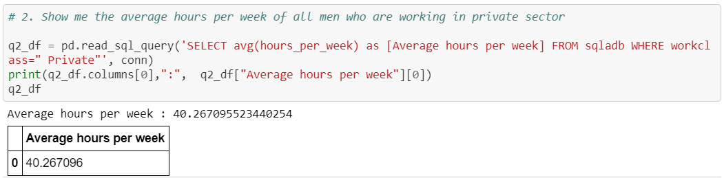

**3. Show me the frequency table for education, occupation and relationship, separately**

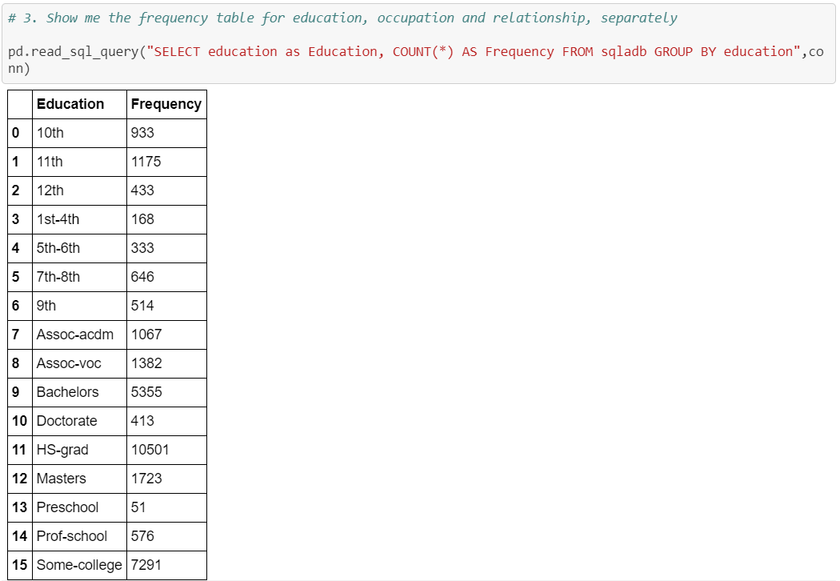

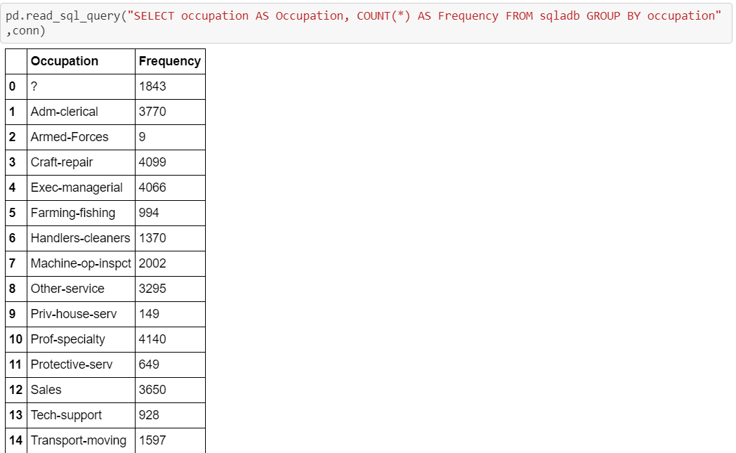

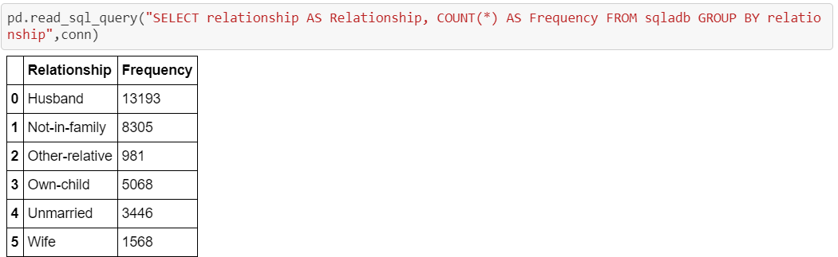

**4. Are there any people who are married, working in private sector and having a masters**

**Degree**

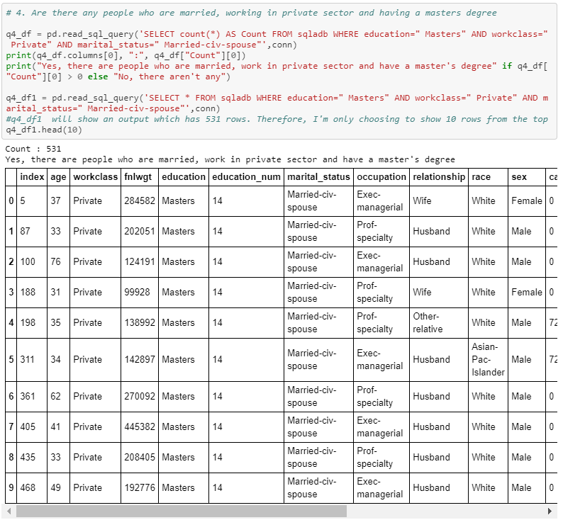

**5. What is the average, minimum and maximum age group for people working in**

**different sectors**

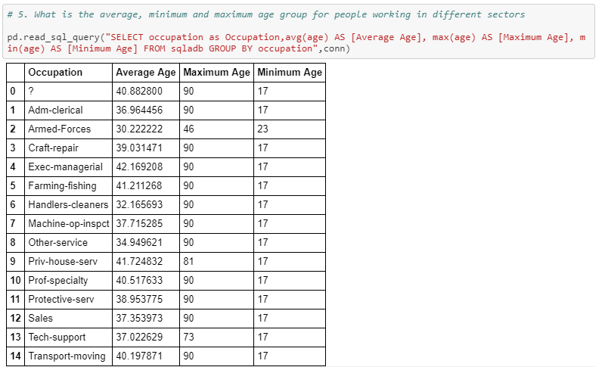

**6. Calculate age distribution by country**

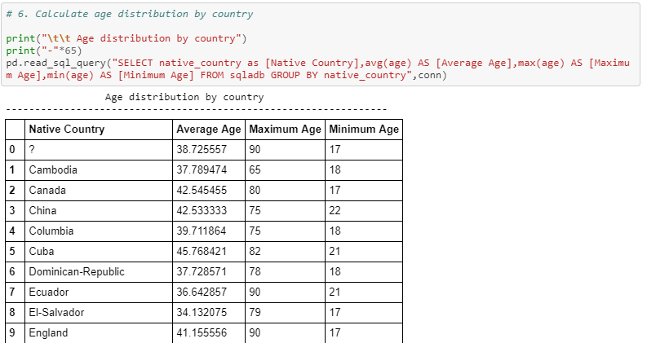

**7. Compute a new column as 'Net-Capital-Gain' from the two columns 'capital-gain' and**

**'capital-loss'**

